MEGA APRILIA SANTOSO

17050623026

D3 MANAJEMEN INFORMATIKA 2017

TUGAS 2 BASIS DATA LANJUT

NOVEL

INDONESIA

FIKSI

NON-FIKSI

HOROR

DRAMA

1. Model Tree Structures With Parent References

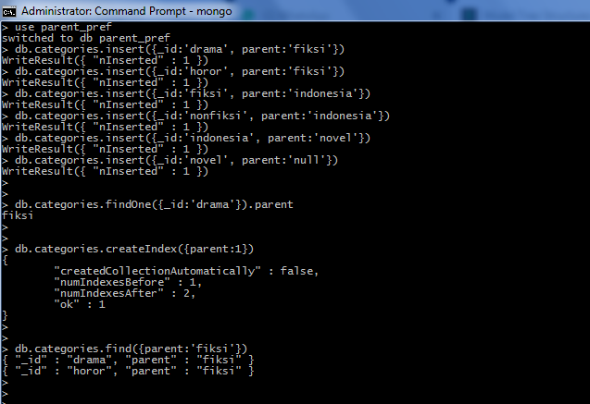

1. Model Tree Structures With Parent References

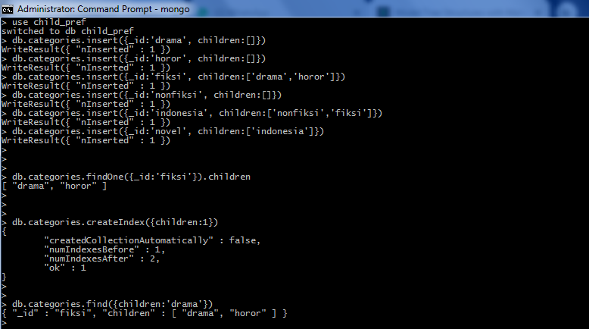

1. Model Tree Structures With an Array of Ancestots

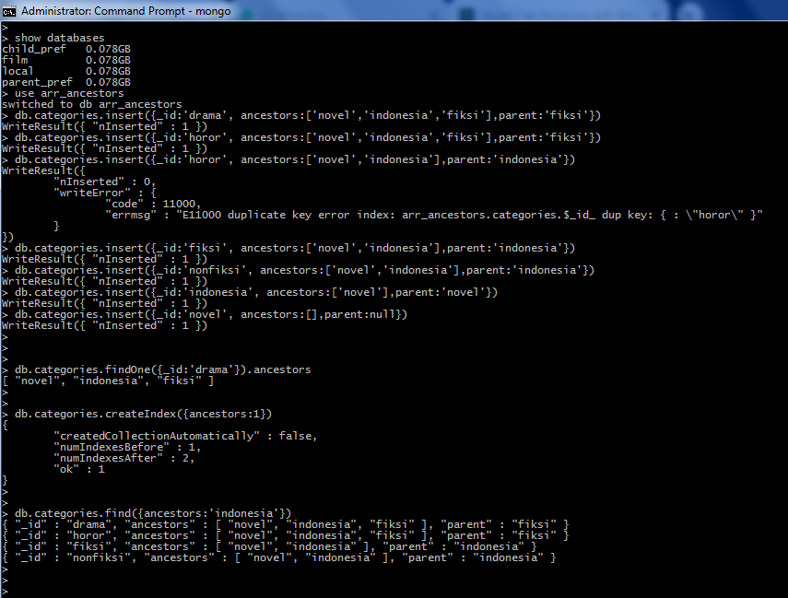

1. Model Tree Structures With Materialized Paths

